**Assignment 6 – Maps in Tableau**

**Part 1: Visualize 10 years of natural disaster data on a visualization map**

**Question A**

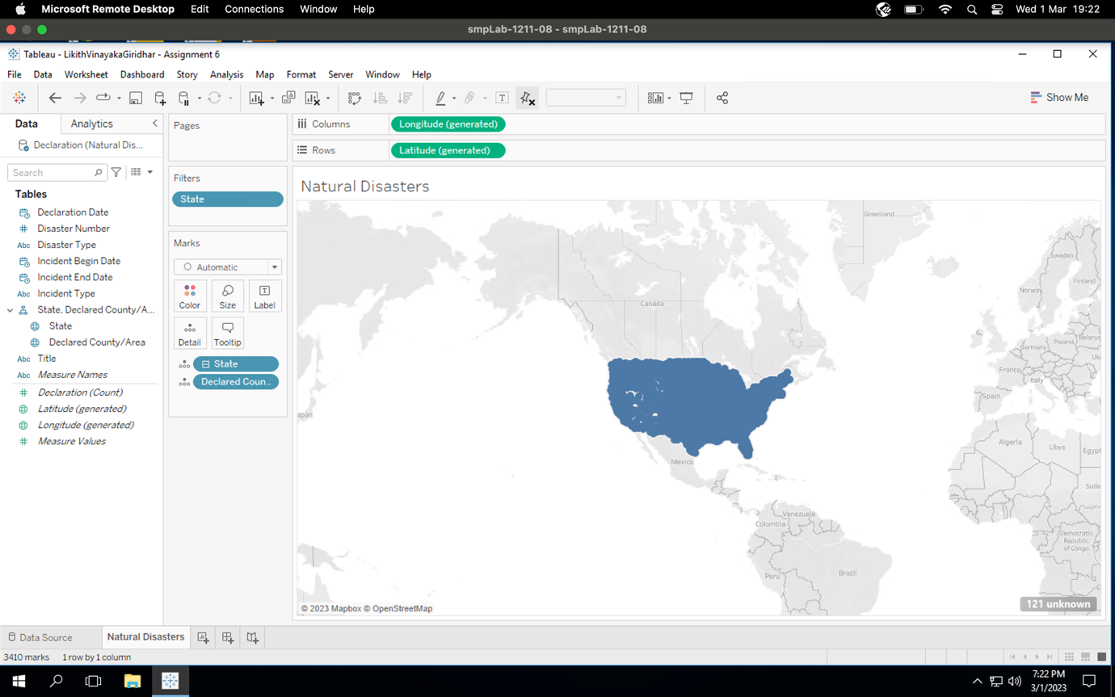

**Question B**

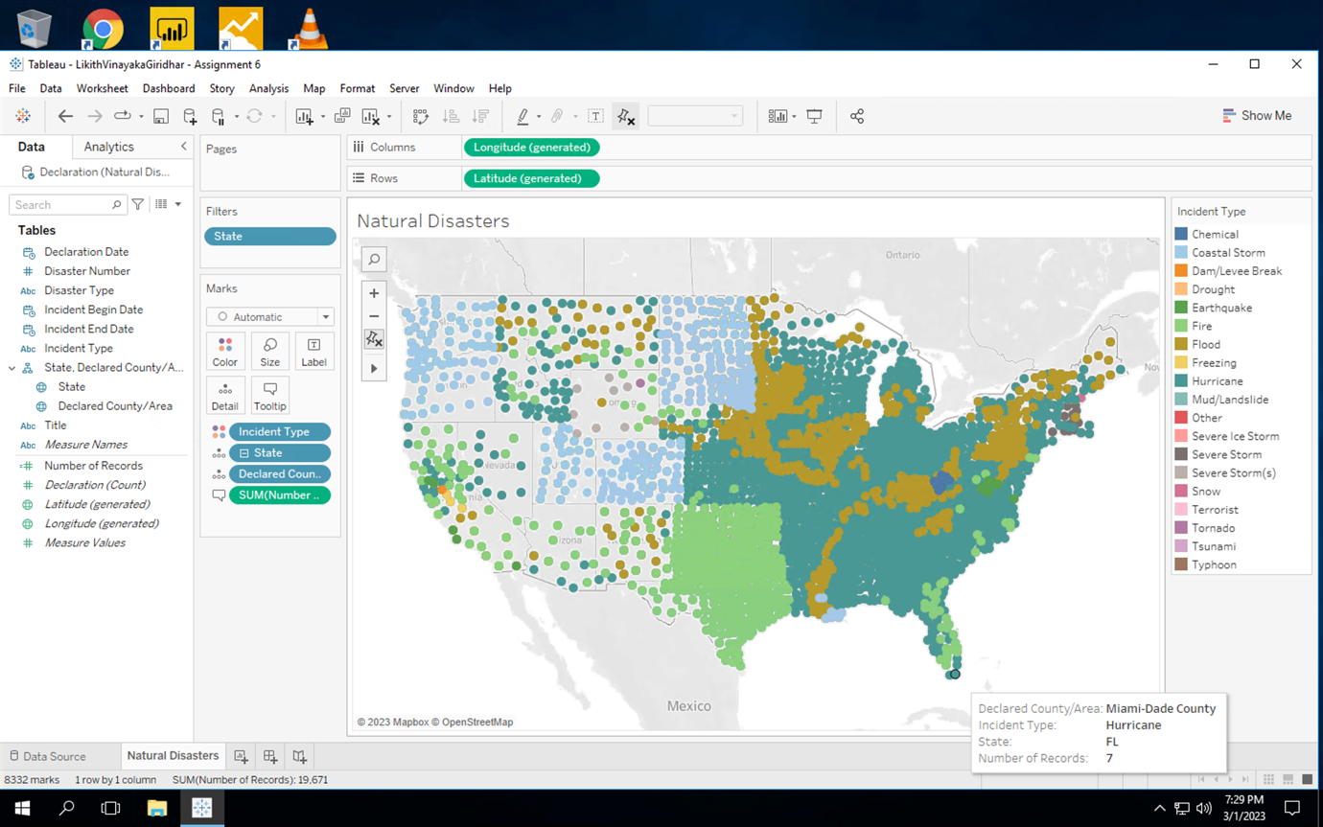

**Question C**

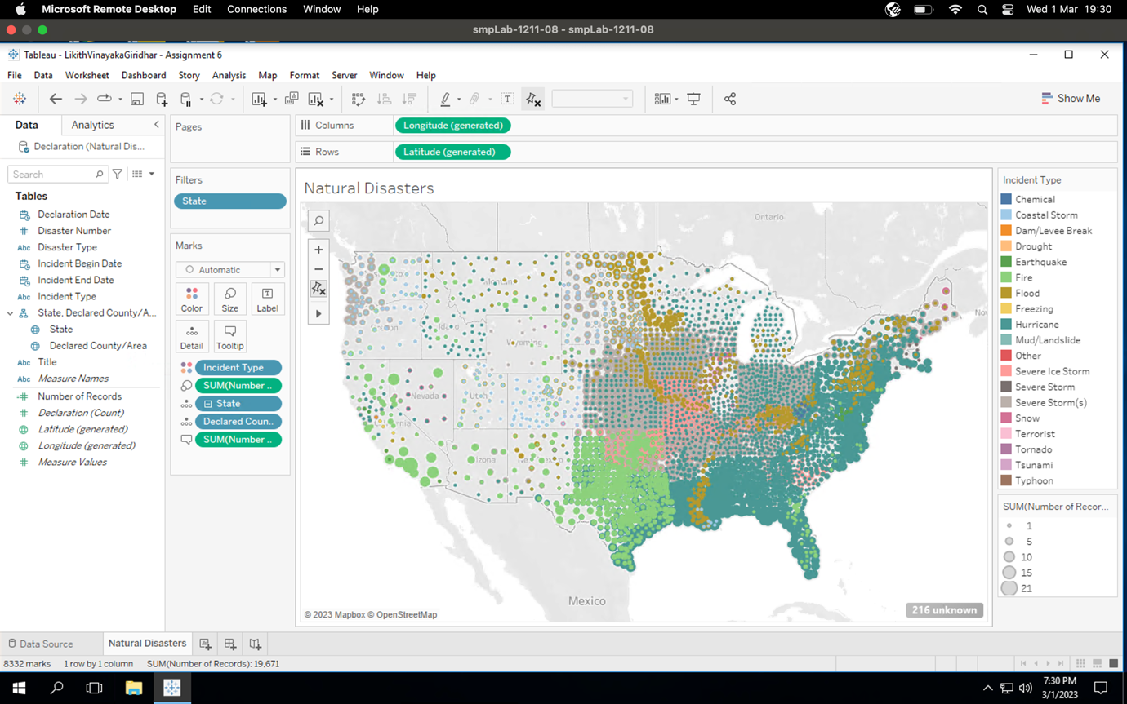

**Question D**

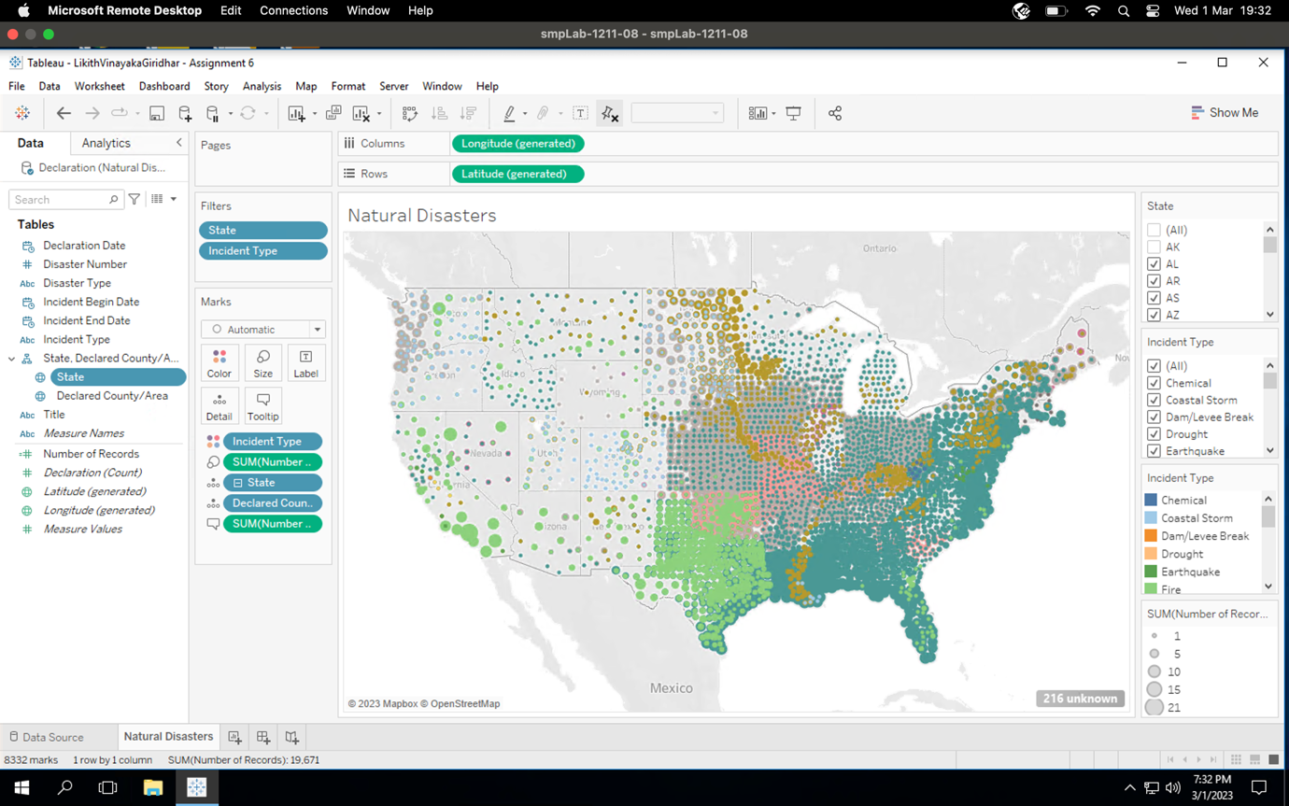

**Question E**

The most prevalent disaster in **Texas** is **Fire** and the most prevalent disaster in **Alabama** is **Hurricane**.

**Question F**

We cannot see Alaska and Hawaii on the map as we have filtered it out from the visualization as a part of step 4 of this Assignment.

**Question G**

We have visually encoded different disasters **using Color**.

**Question H**

We have visually encoded number of disaster incidents in a county **using Size**.

**Part 2: Visualize all refinery locations for one ‘Energy Company’**

**Question I**

Refinery Name: Chevron USA Inc Pascagoula Refinery

Corporation: Chevron Corp

Company: Chevron USA Inc

* State – Mississippi
* County – Jackson County

Refinery Name: Chevron USA Inc El Segundo Refinery

Corporation: Chevron Corp

Company: Chevron USA Inc

* State – California
* County – Los Angeles County

Refinery Name: Chevron USA Inc Richmond Refinery

Corporation: Chevron Corp

Company: Chevron USA Inc

* State – California
* County – Contra Costa County

Refinery Name: Chevron Corp Pasadena Refining Systems Inc Pasadena Refinery

Corporation: Chevron Corp

Company: Pasadena Refining Systems Inc

* State – Texas
* County – Harris County

Refinery Name: Chevron USA Inc Salt Lake City Refinery

Corporation: Chevron Corp

Company: Chevron USA Inc

* State – Utah
* County – Salt Lake County

**Question J**

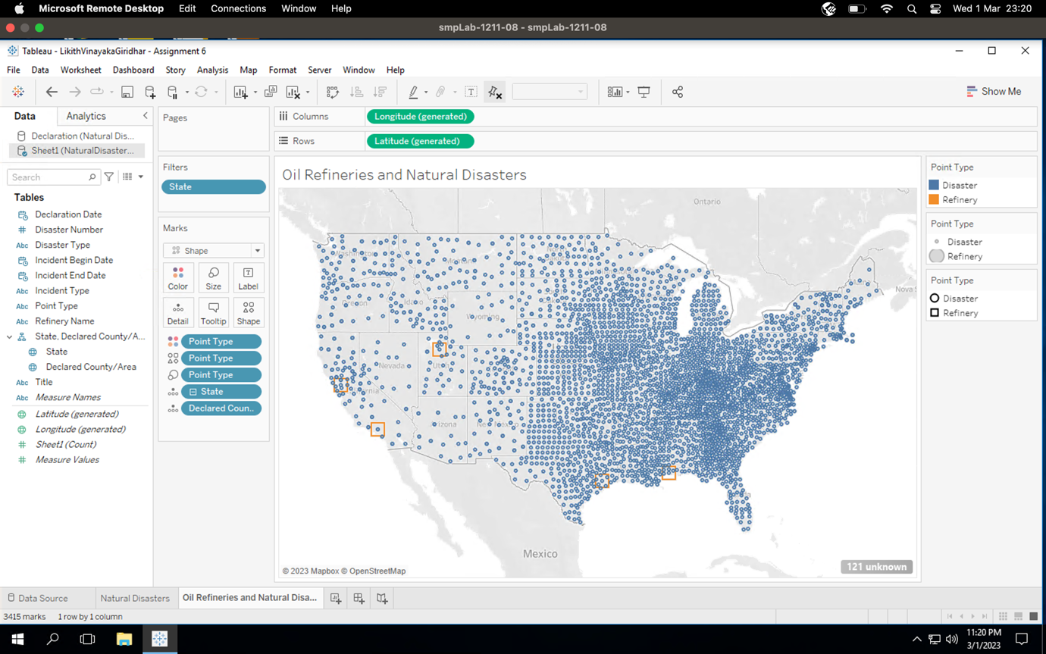

**Question K**

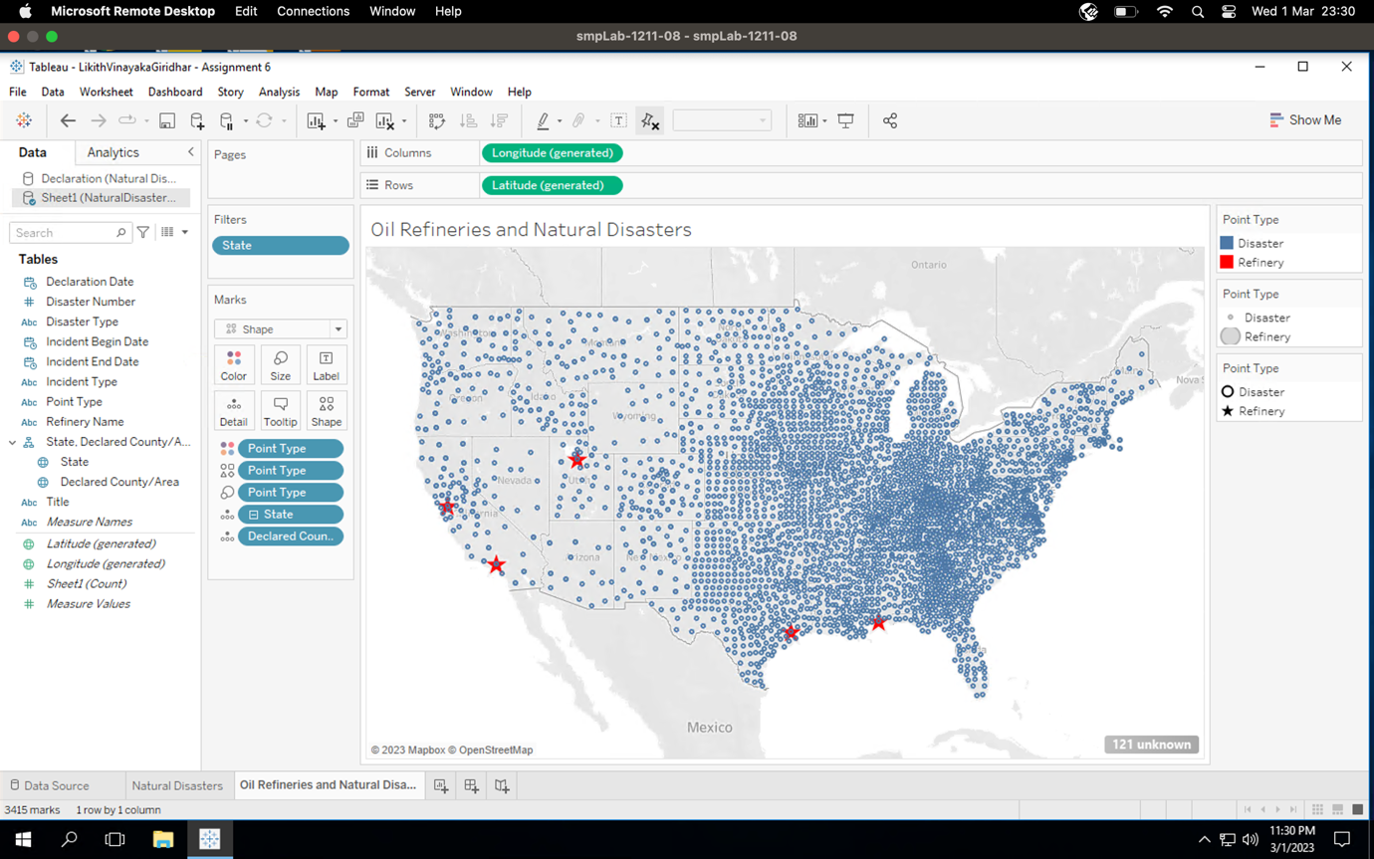

**Question L**

1. California
2. Utah
3. Texas
4. Mississippi

**Part 3: Visualize refinery states**

**Question M**

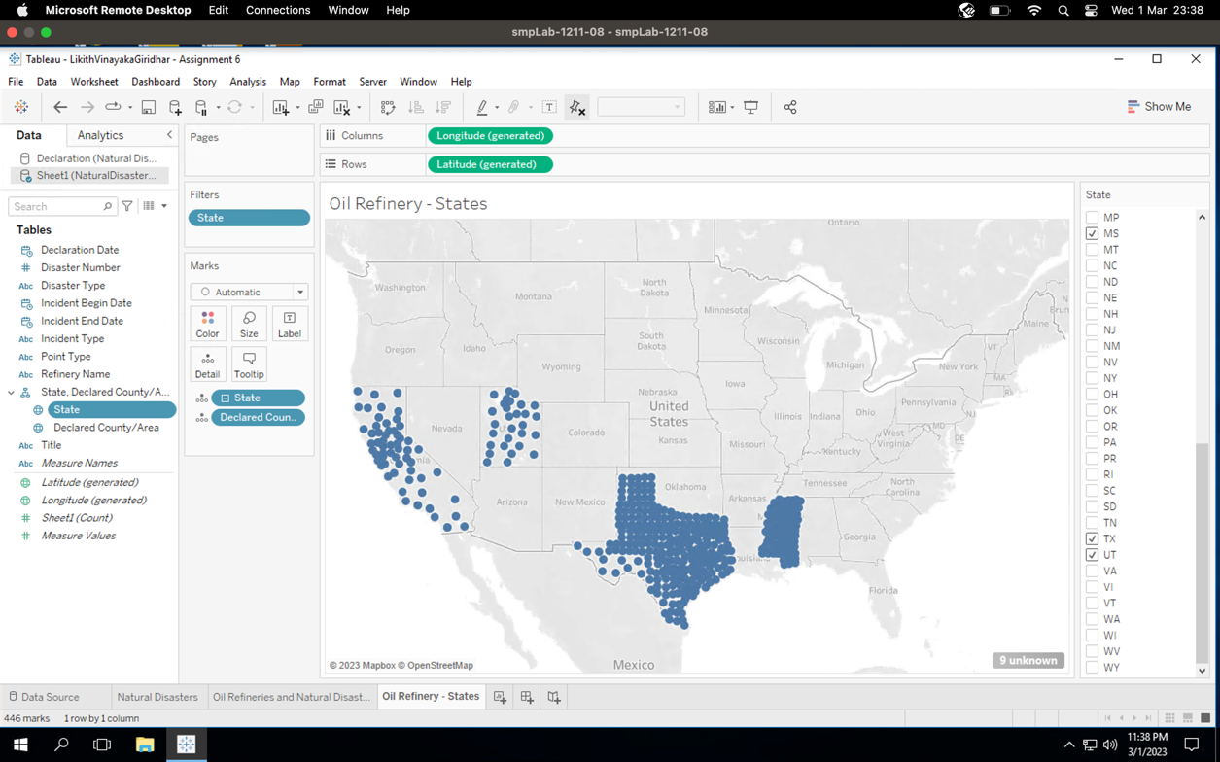

**Question N**

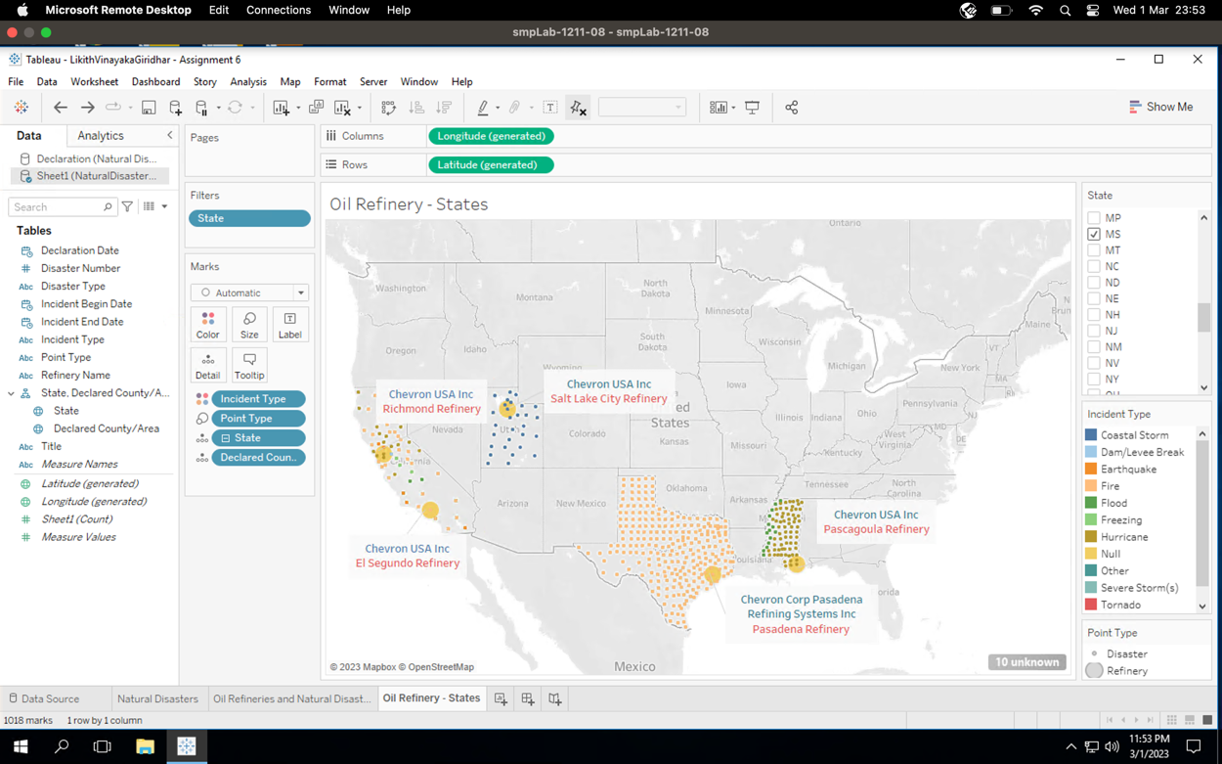

**Question O**

The disasters impacting Texas are:

* Fire

The disasters impacting Mississippi are:

* Hurricane
* Flood

The disasters impacting California are:

* Fire
* Earthquake
* Flood
* Freezing
* Hurricane
* Dam/Leevee Break

The disasters impacting Utah are:

* Coastal Storm

**Part 4: Find top 4 disasters impacting refinery locations**

**Question P**

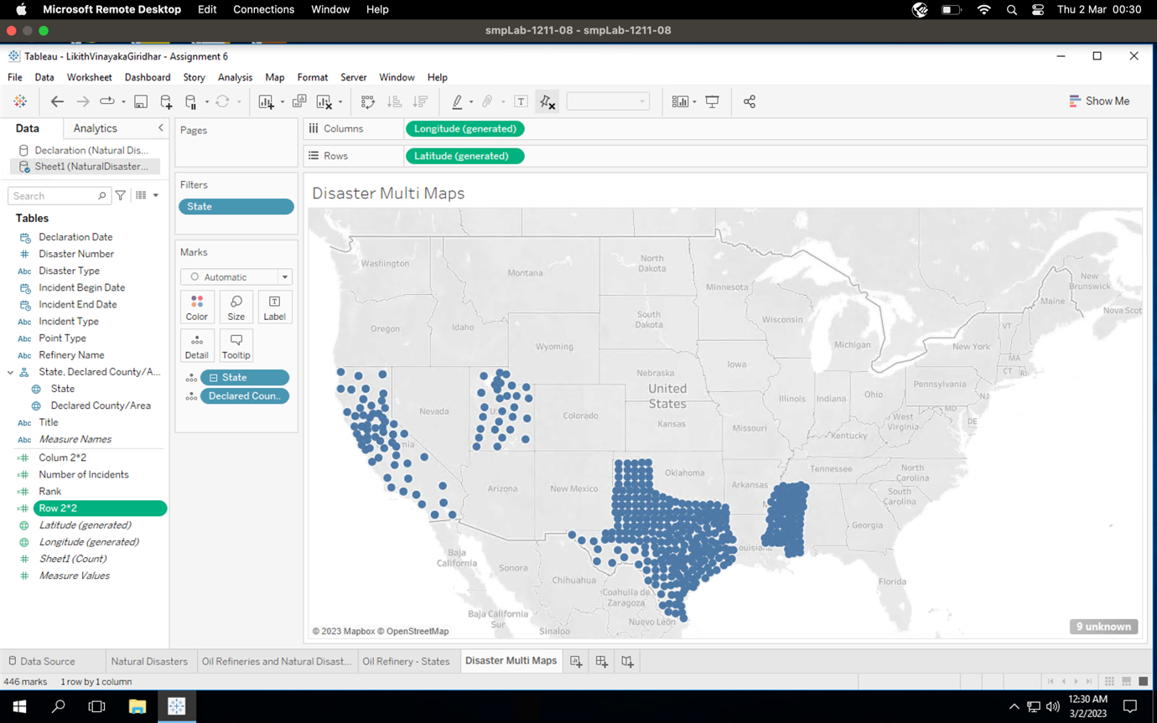

**Question Q**

**Considering states with the selected refineries:** Hurricane is ranked 1st

**Considering all the states:** Severe Storm(s) is ranked 1st

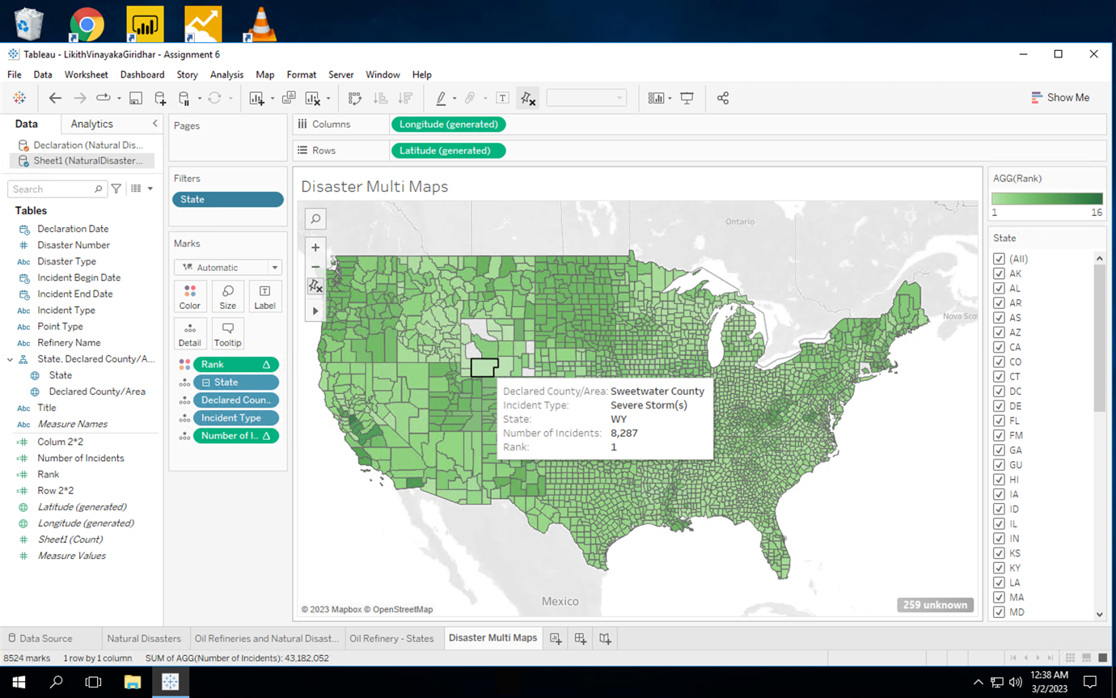

**Question R**

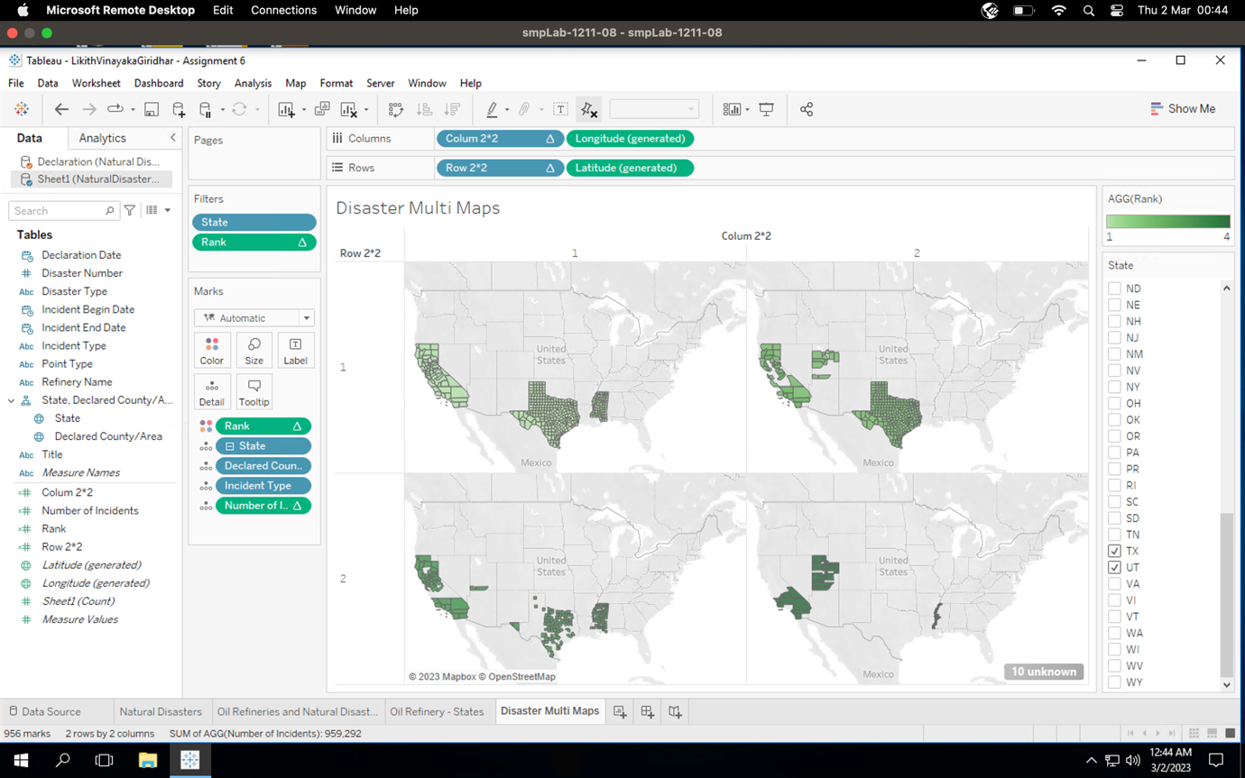

**Question S**

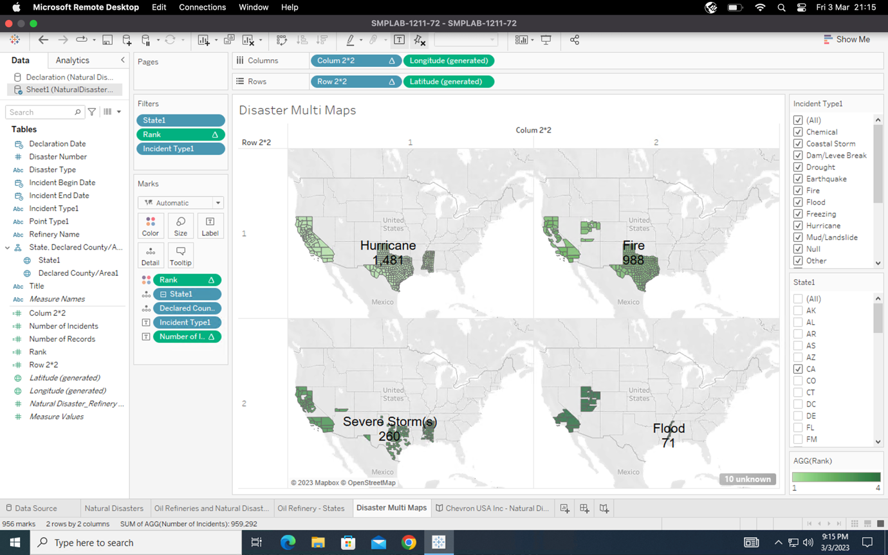

**Question T**

The calculated fields generate quantitative numeric values and hence got added as Measures.

**Question U**

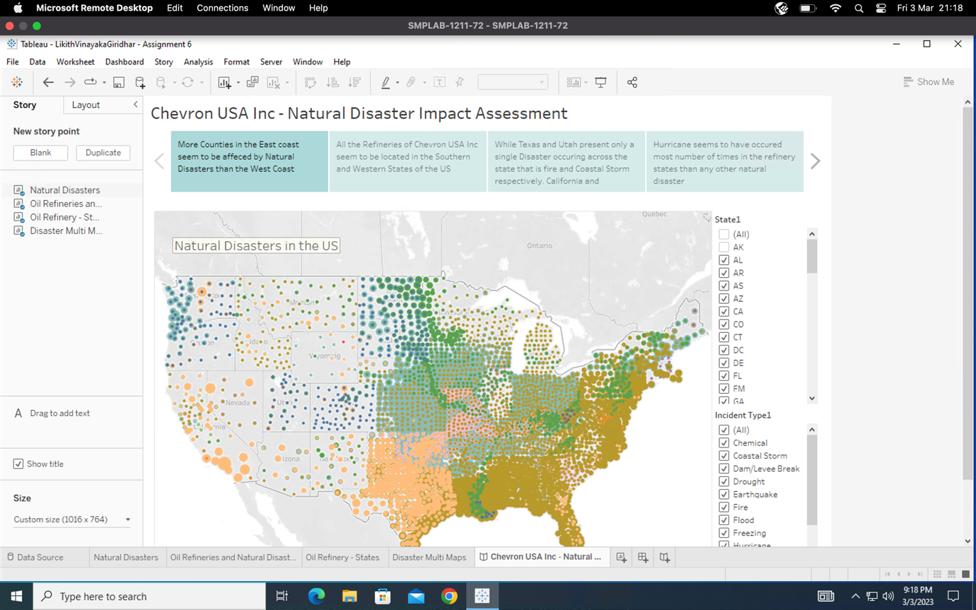

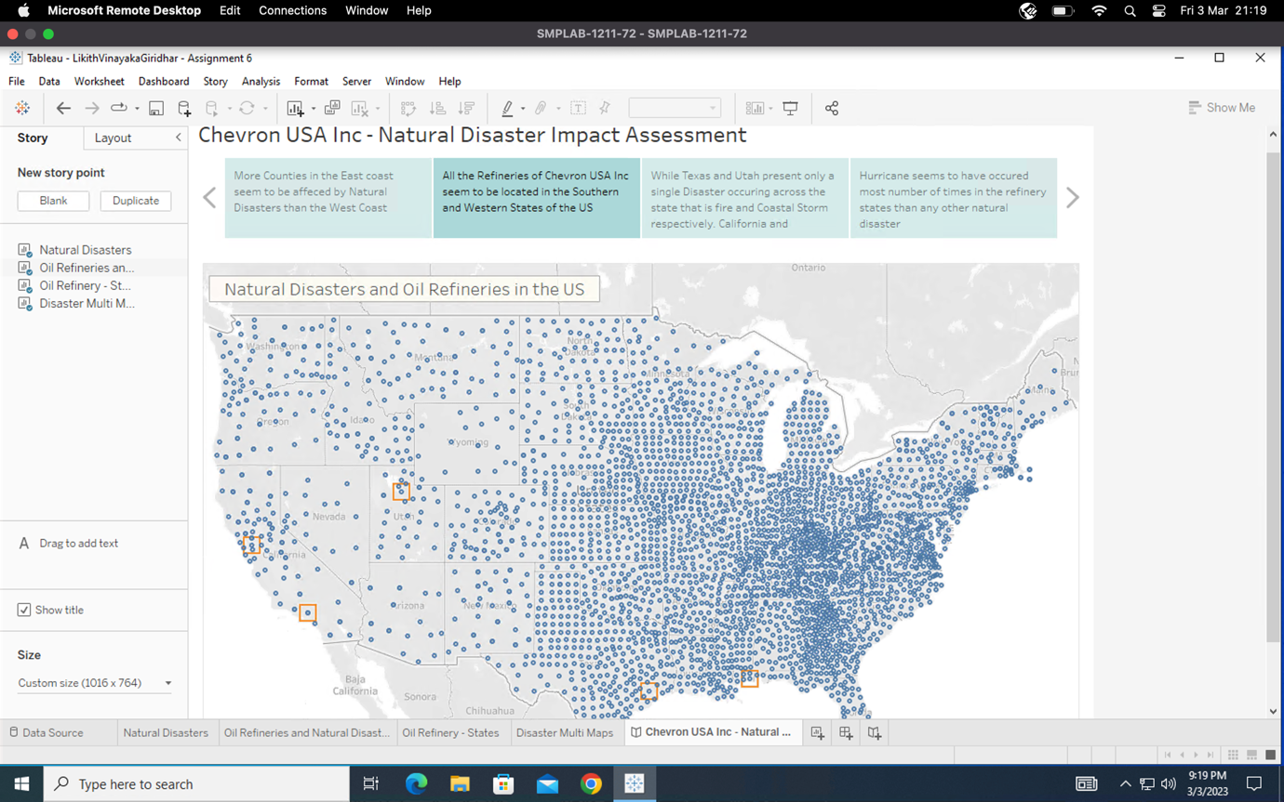

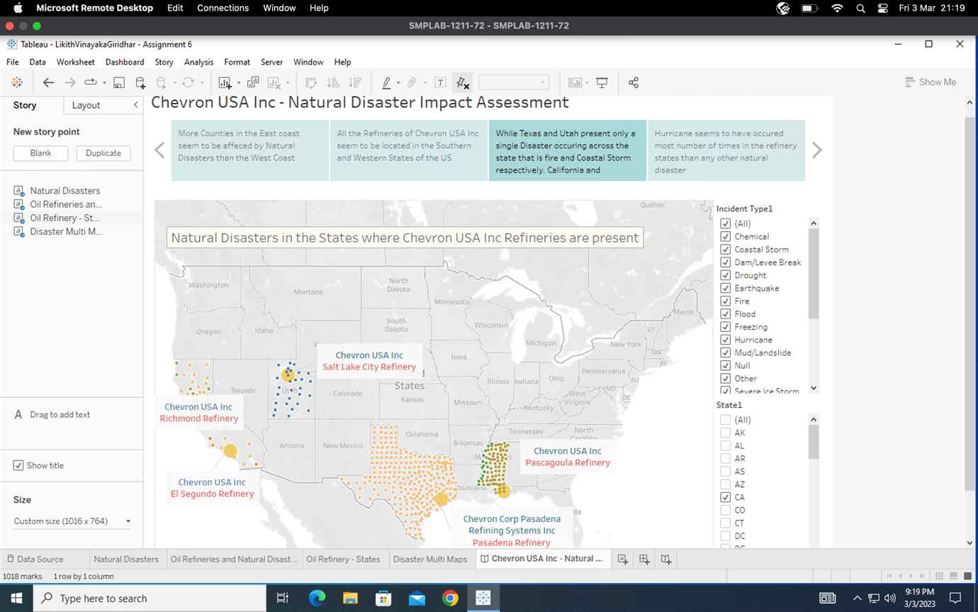

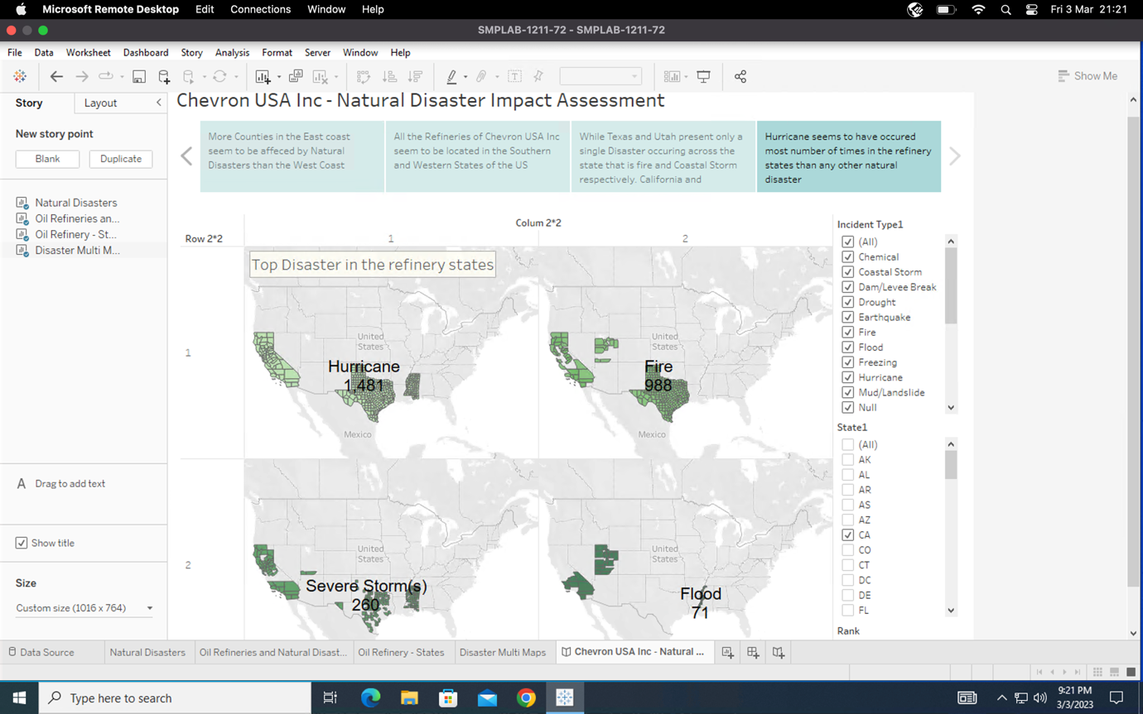

**Question V**

* We have used a logical rhetoric in the story we have built right now.
* We first assess the spread of natural disasters across all the states of the US then we move our focus to disasters occurring in the states where the oil refineries of Chevron USA Inc are located at.
* Since we are analysing metrics like the count of particular disasters and ranking them to determine the top disasters in our refinery sites, the logical rhetoric seems appropriate here. We develop our plot logically and ultimately identify the worst catastrophes in these areas.